LAB-12.
Find the addition of 3x3 matrix using MATLAB.
Ans:
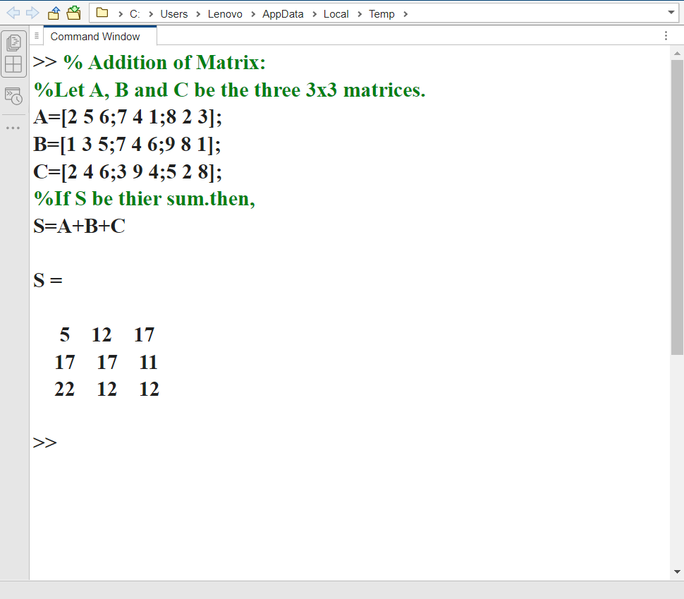

LAB-13.
Find the subtraction of 3x3 matrix using MATLAB.
Ans:
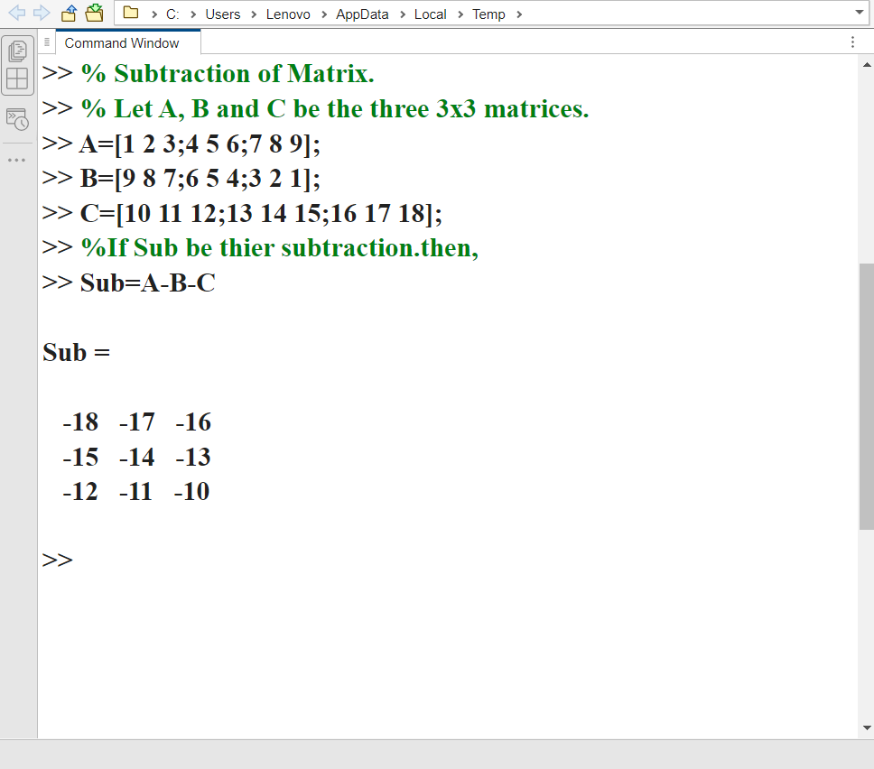

LAB-14.
Find the multiplication of 3x3 matrix using MATLAB.
Ans:
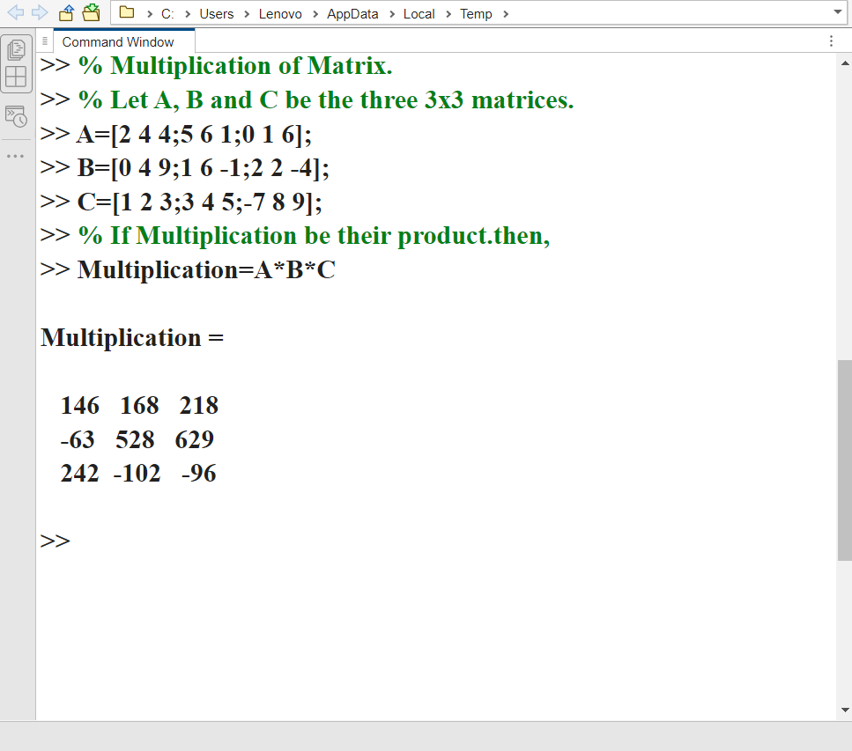

LAB-15.
Find the transpose of the 3x3 matrix using MATLAB.
Ans:
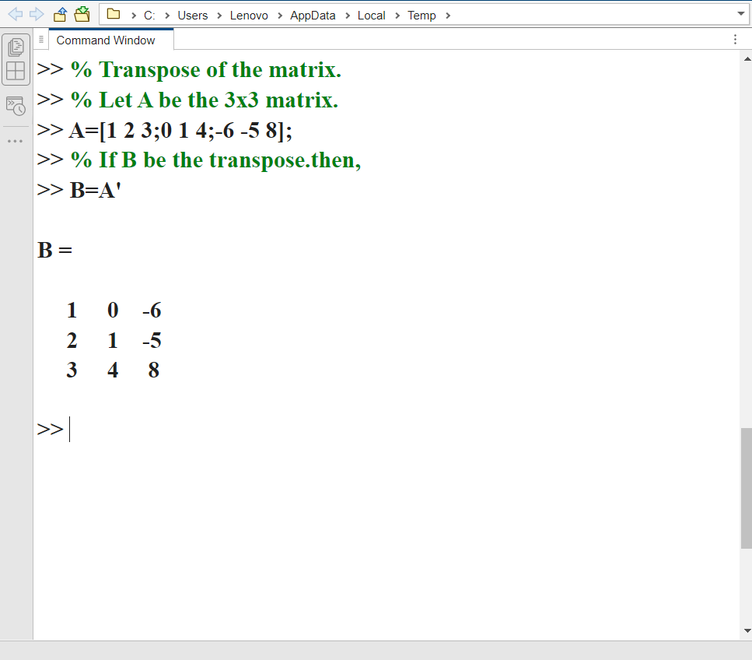

LAB-16.
Find the Rank of the matrix using MATLAB.
Ans:
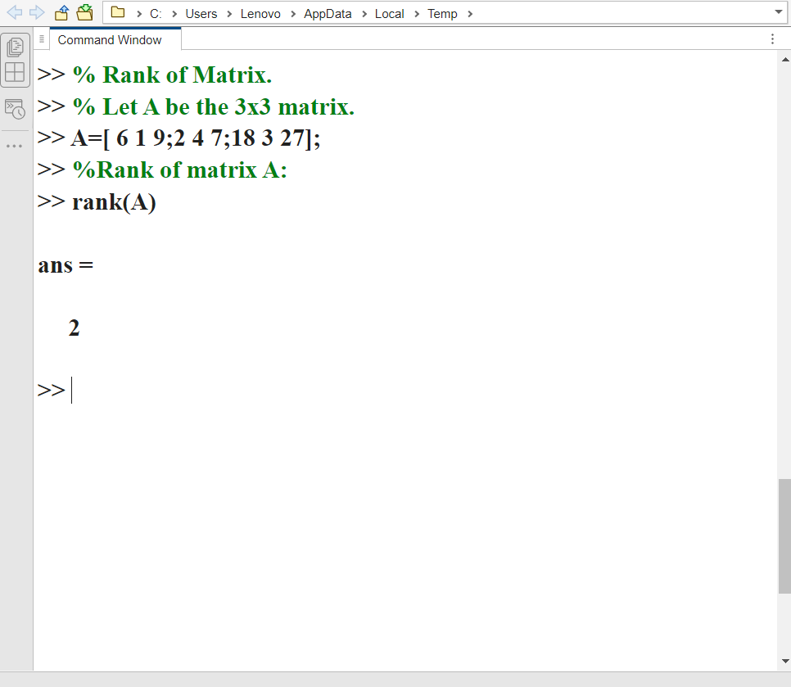

LAB-17.
Find the Determinant of matrix using MATLAB.
Ans:
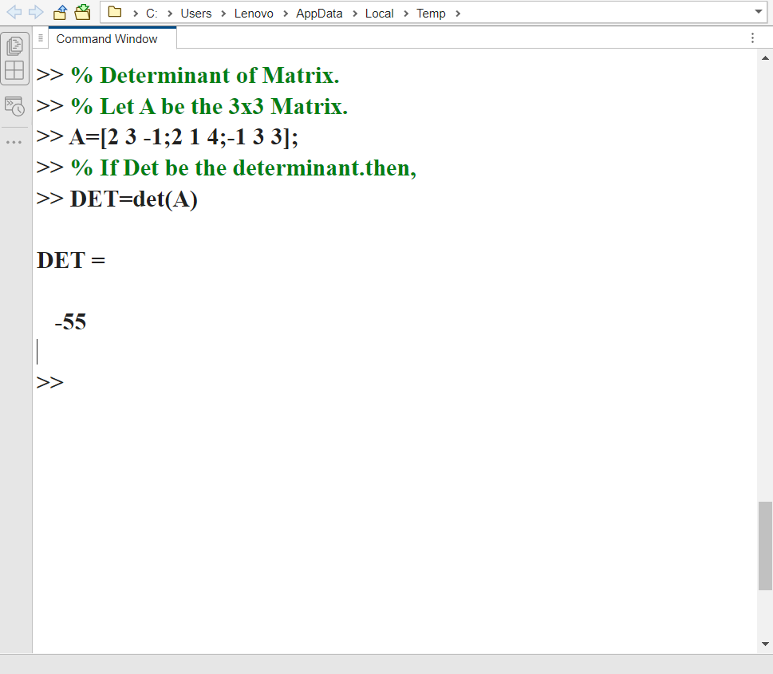

LAB-18.
Find the Inverse of 3x3 matrix using MATLAB.
Ans:
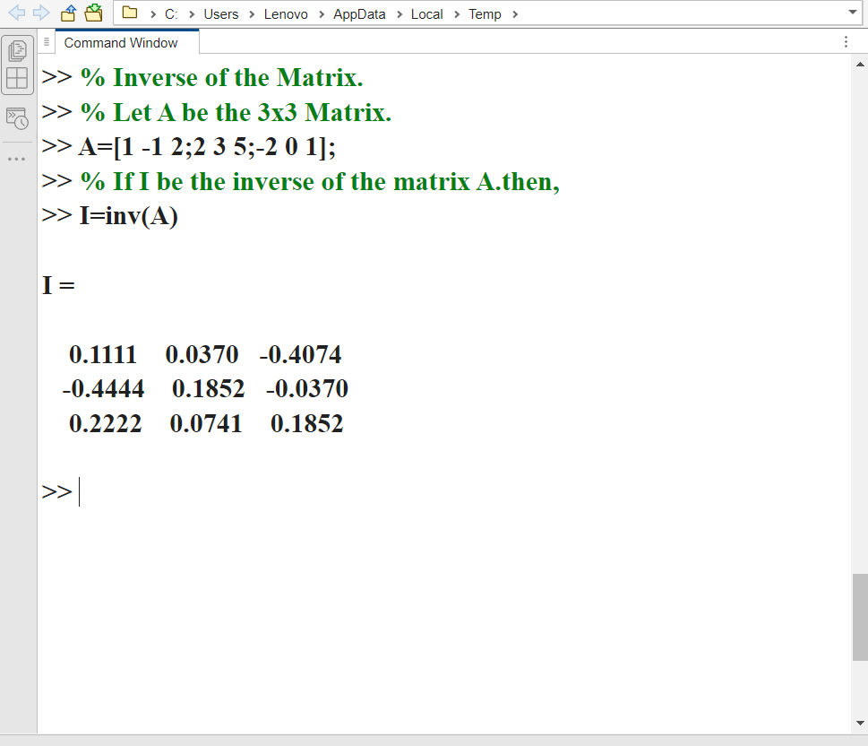

LAB-19.
Find the Adjoint of 3x3 matrix using MATLAB.
Ans:
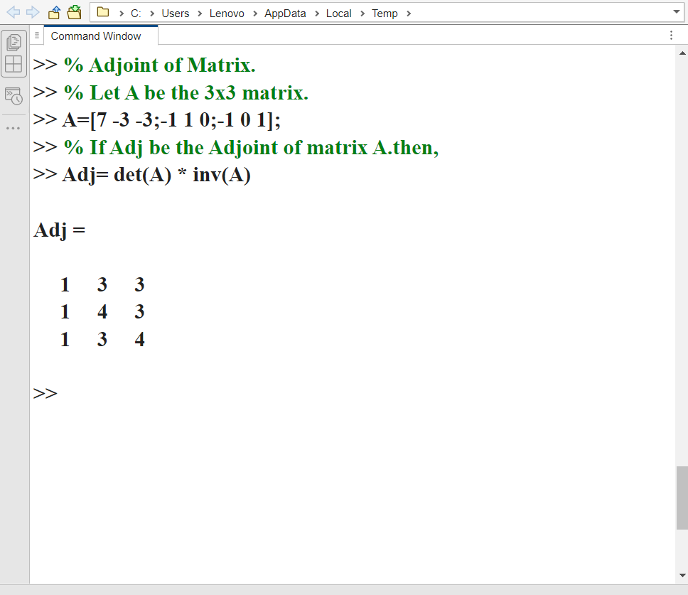

LAB-20.
Find the Eigenvalues and Eigenvector of 3x3 matrix using MATLAB.
Ans:
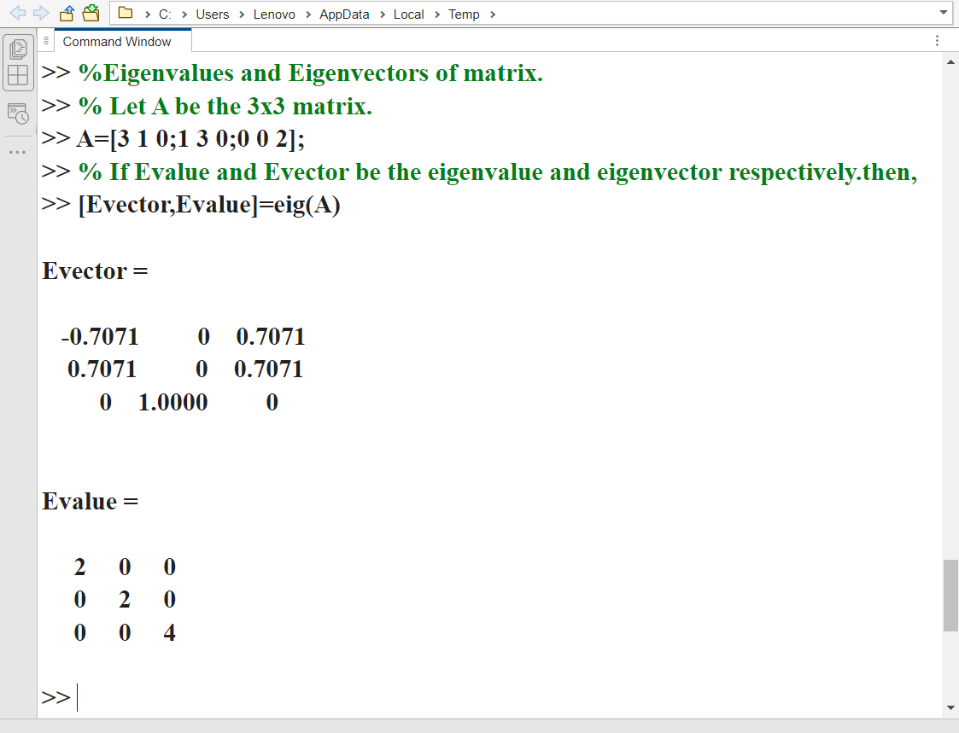

LAB-21.
Find the Scalar (dot) product of two vectors.
Ans:
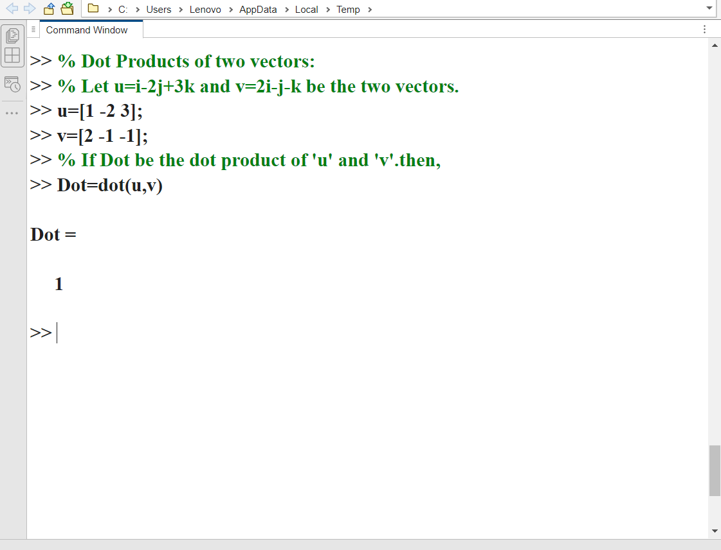

LAB-22.
Find the Vector (cross) product of two vectors.
Ans:
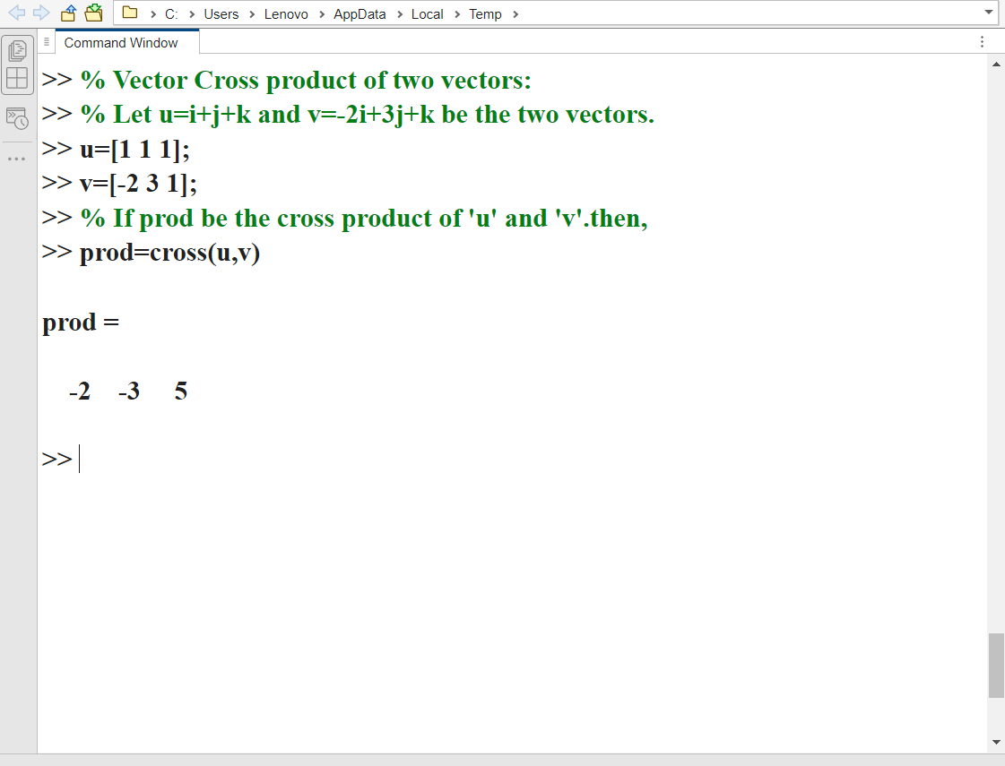

LAB-23.
Find the Scalar product of three vectors using MATLAB.
Ans:
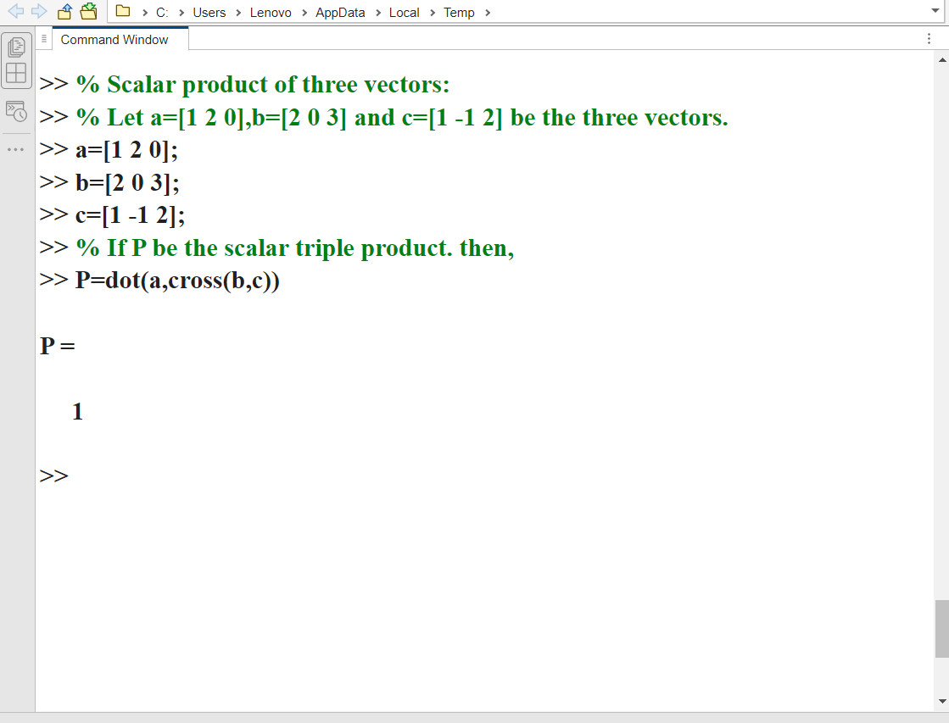

LAB-24.
Find the Vector product of three vectors using MATLAB.
Ans:
